Hybrid Thermal Storage (Latent + Sensible Heat)

As we know our world is moving forward in all sector like Space, Medical, Automation, etc. The core or life line of human evolution is Energy. We have evolved the techniques that can transform Energy phase and make it easily accessible to mass.

**In late 1800s – Early 1900s**: Small-scale **diesel and gasoline engines** began powering:

* Water pumps
* Mills and factories
* Electrical generators for local lighting

But this results in Environmental Pollution and High **mechanical vibrations** make them unsuitable in residential or sensitive environments without noise isolation. There was a surge need of alternative .

**So, in 2020s – Green Energy Goes Mainstream**

* **Paris Agreement (2015)** accelerated global commitments.
* **Net-zero targets** set by over 140 countries.
* Green energy became **cheaper** than fossil fuels in many regions.
* **Battery storage, green hydrogen**, and **grid integration** technologies matured.
* Surging investment in **EVs**, **solar rooftops**, **floating solar**, and **hybrid renewable systems**

**The main green energy source is SUN .Earth receives nearly 174,000 terawatts of solar energy continuously. That’s over 10,000 times the world’s current energy use.**

**To use this energy human start trapping the energy by various method Our method is one of those method. Our method is to store that heat energy into the form of Sensible and Latent heat**

**Sensible heat is the heat energy that causes a change in the temperature of a substance without changing its phase. It can be felt or "sensed" and is measured using a thermometer. For example, heating water from 20°C to 80°C involves sensible heat.**

**In latent heat is the energy absorbed or released during a phase change at constant temperature, such as melting, boiling, or condensation. For instance, when ice melts into water or water vaporizes into steam, the temperature stays the same, but latent heat is involved in changing the state.**

**And All that heat is gathered by CSP(Concentrated solar power) system.**

**Concentrated Solar Power (CSP)** is a renewable energy technology that uses **mirrors or lenses to concentrate sunlight** onto a small area to **generate heat**. Our CSP system contains **thermal energy storage**, which traps heat energy in day and allowing electricity generation even when the sun isn't shining. CSP is best suited for regions with **high direct sunlight and is typically used for large-scale power plants.**

Here our work is to run simulation readings on thermal energy storage. So, we design a Thermal Storage system in Ansys Fluent.

For,

For,

Latent heat storage – pure anhydrous Mgcl2 is used

Sensible heat storage – Basalt rock is used

Making heat transfer more effective – copper tube with fins is used

A constant heat source is added at centre .

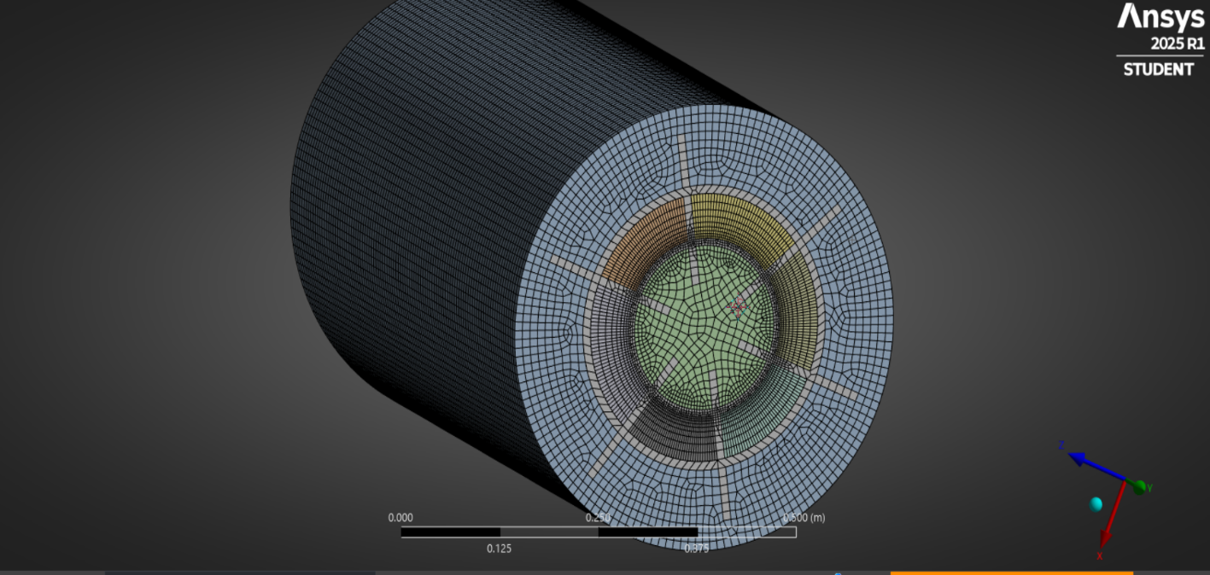

Fig: Full body

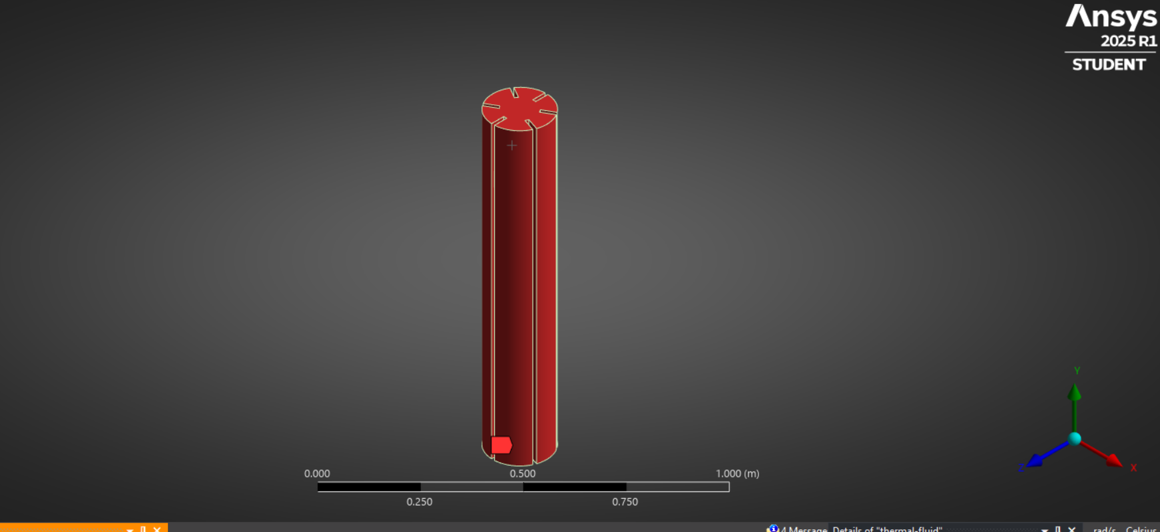 fig: heat source

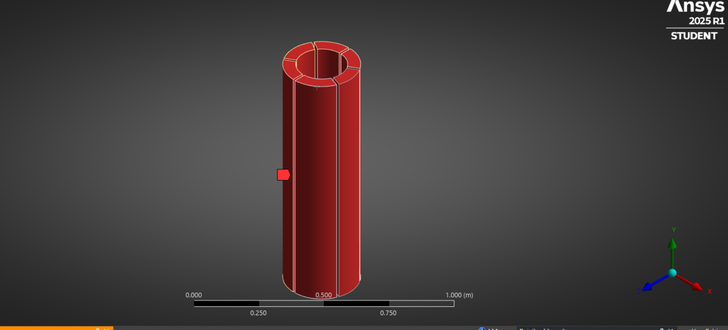 Fig: PCM

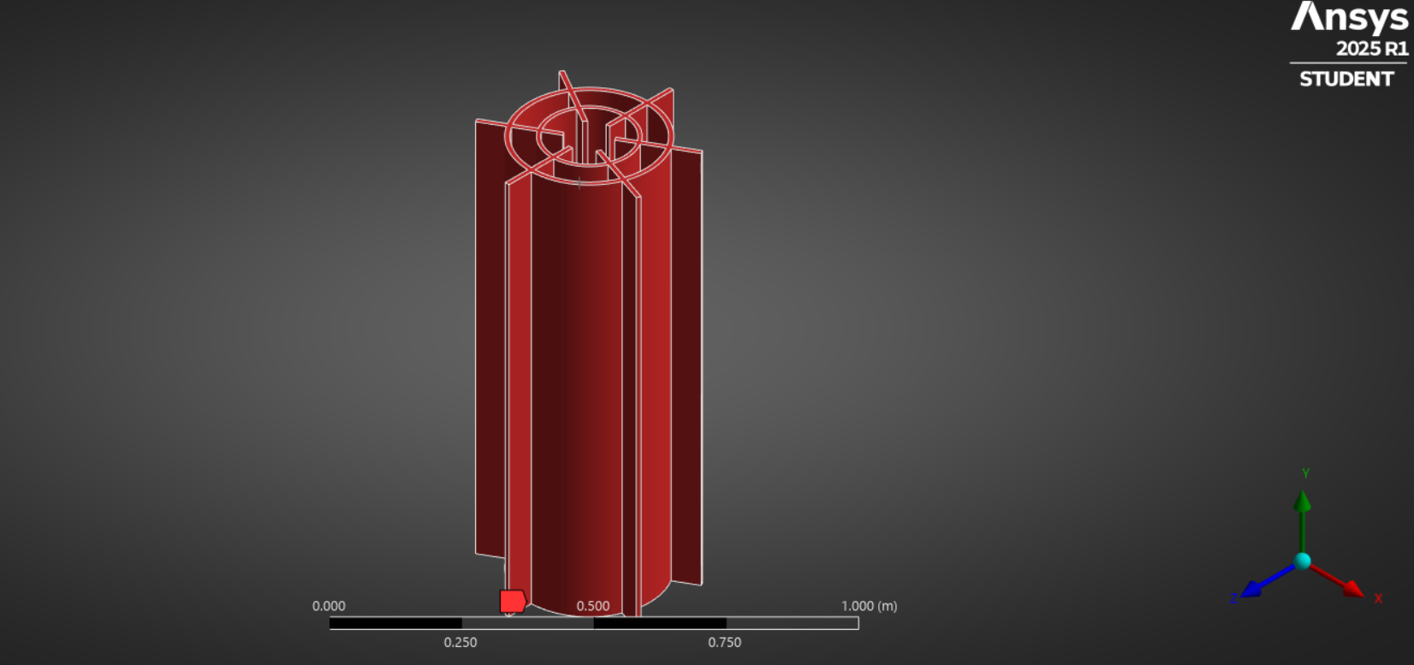

Fig: Copper Conductor

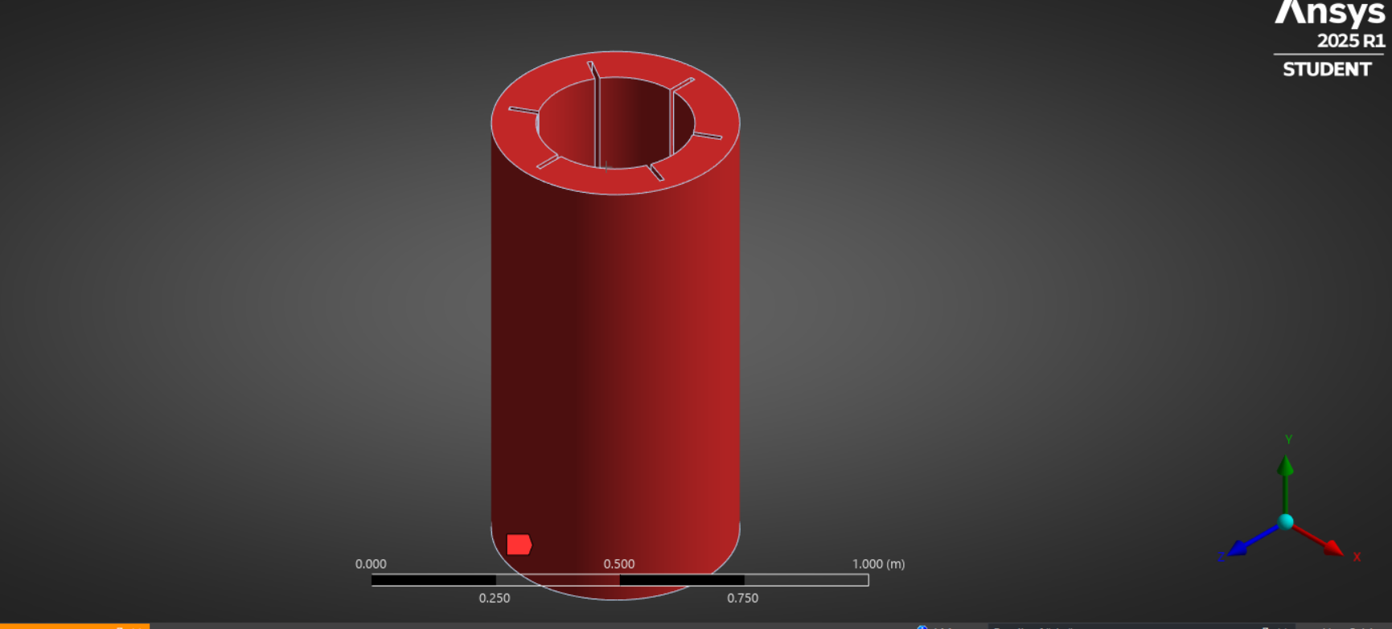 Fig: Sensible Heat Storage

Some physical properties of apparatus

volume of heat source = 0.02407029 m^3

heat flux = 238000 W/m^3

volume of PCM = 0.03629351 m^3

mass of PCM= 78.46544 kg

latent heat of fusion= 454 KJ/Kg

Melting temp = 987.15 k

volume of shs =0.1123694 m^3

mass of shs = 348.345 kg

total volume of apparatus=0.1963372 m^3

total mass of apparatus =834.94331 Kg

For MgCl2--

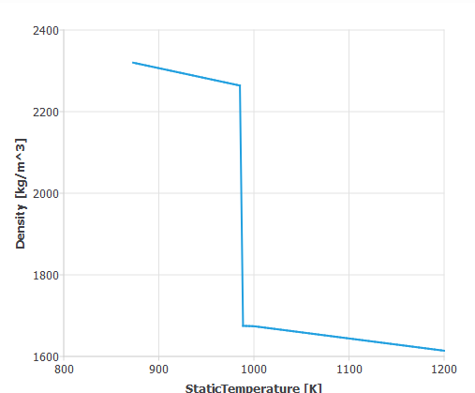

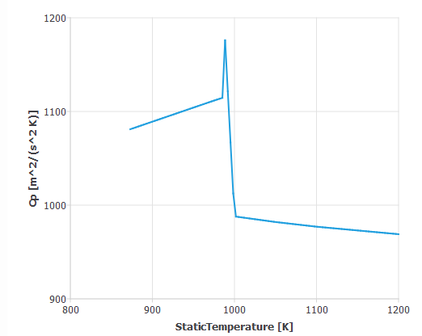

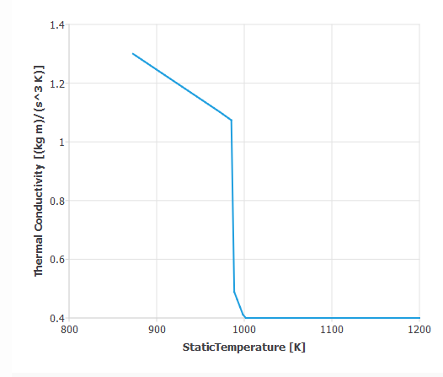

For Basalt Rock –

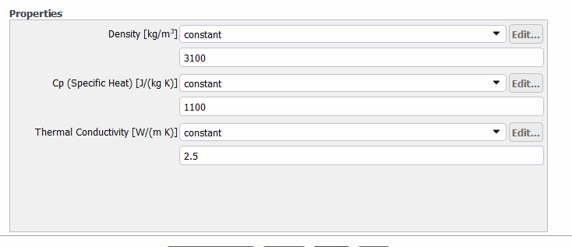

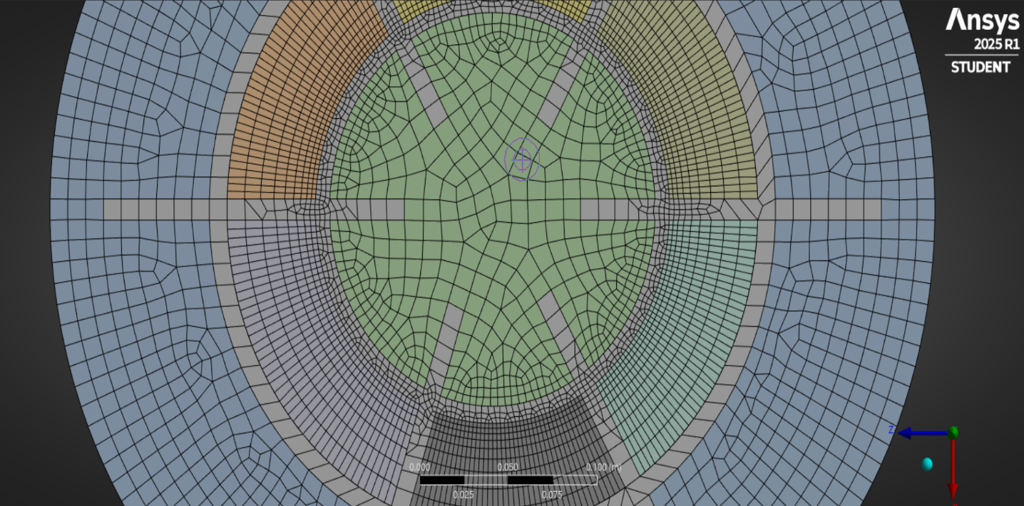

Conformal meshing and Nodes match had done for efficient performance .

Models used for it in Ansys are – Energy ,Viscous model (epsilon) & solidification and melting.

Here we arranged apparatus in two different positions

1. Horizontal

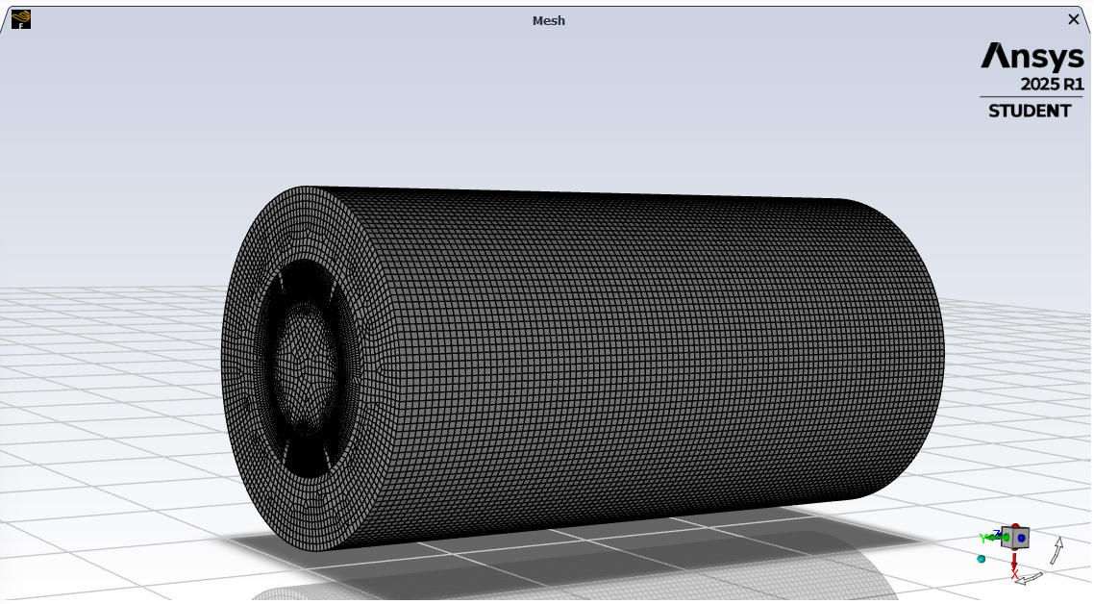

1. At 45 degree tilt

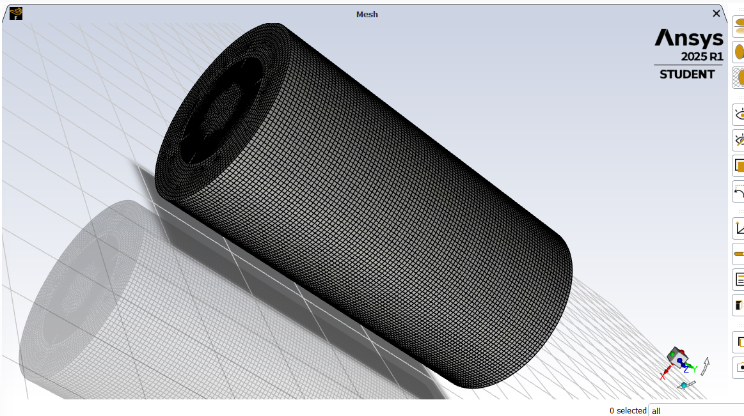

For Horizontal placed apparatus, temperatures and enthalpy of pcm and shs are

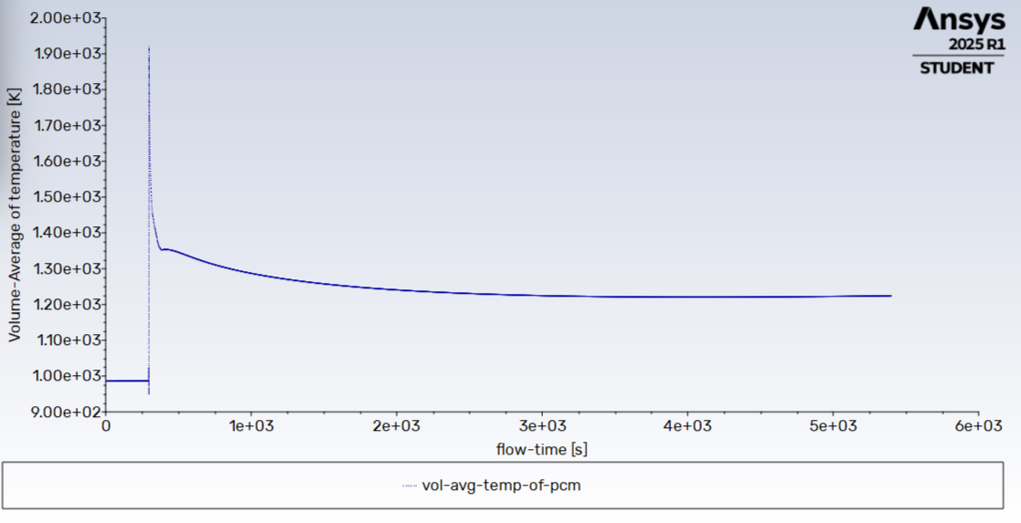

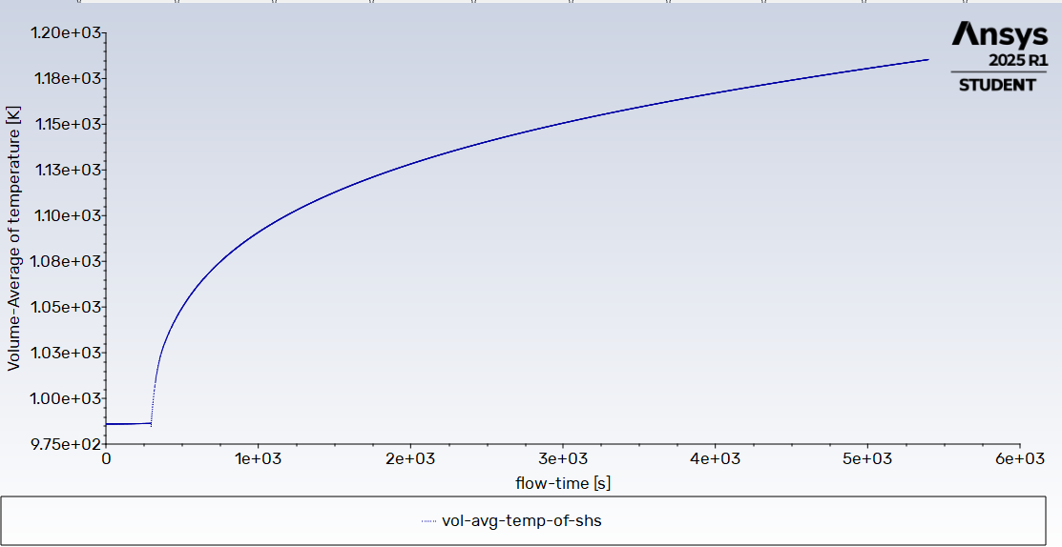

Enthalpy absorbed by Pcm in this time – 14,33,861 J/Kg

Enthalpy absorbed by Shs in this time 9,75,957.6 J/Kg

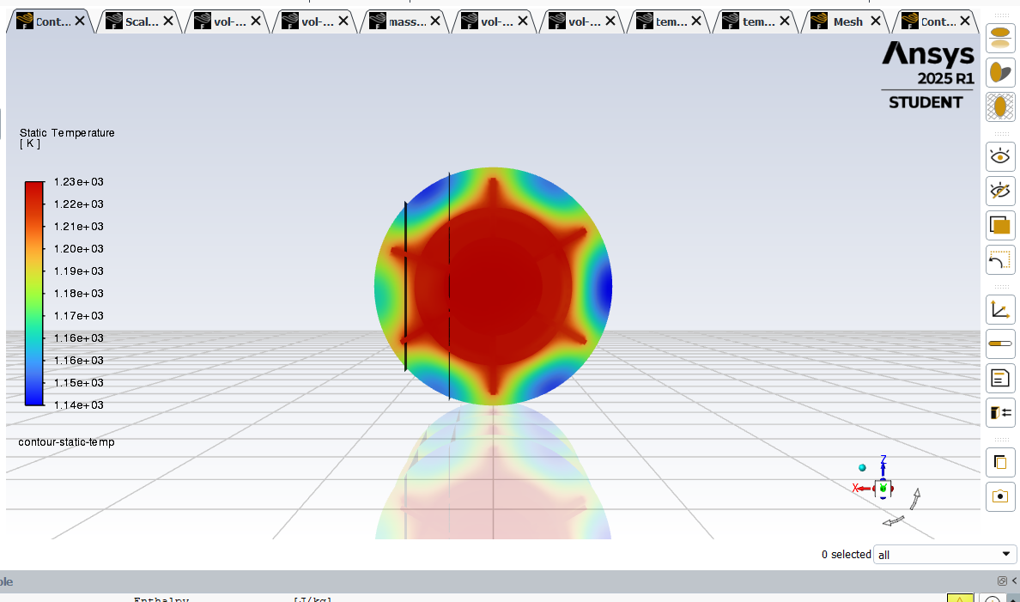

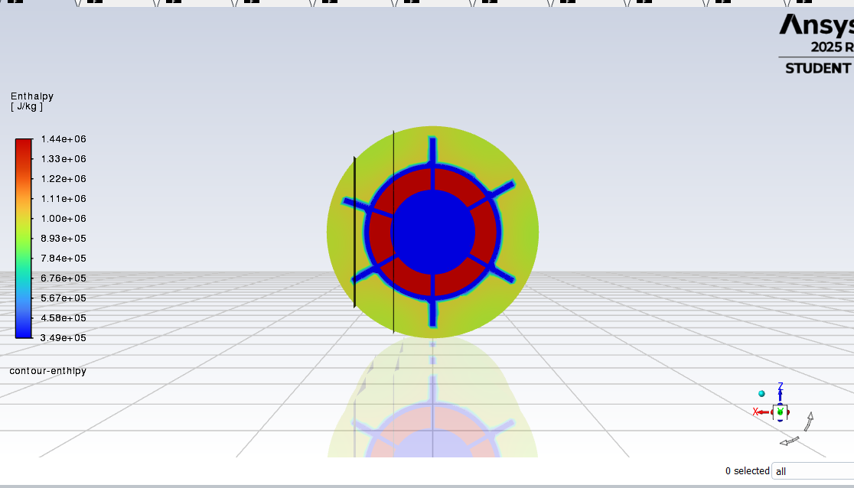

When apparatus is kept at 45 degree tilt , , temperature and enthalpy of pcm and shs are

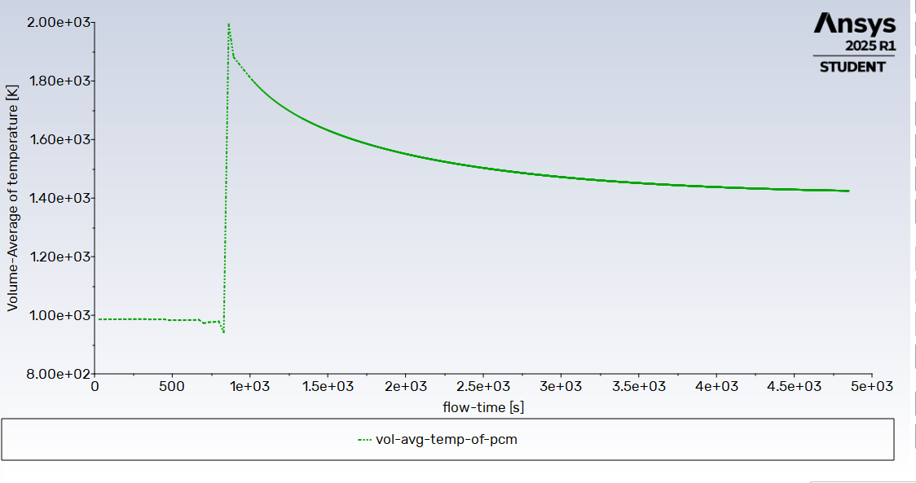

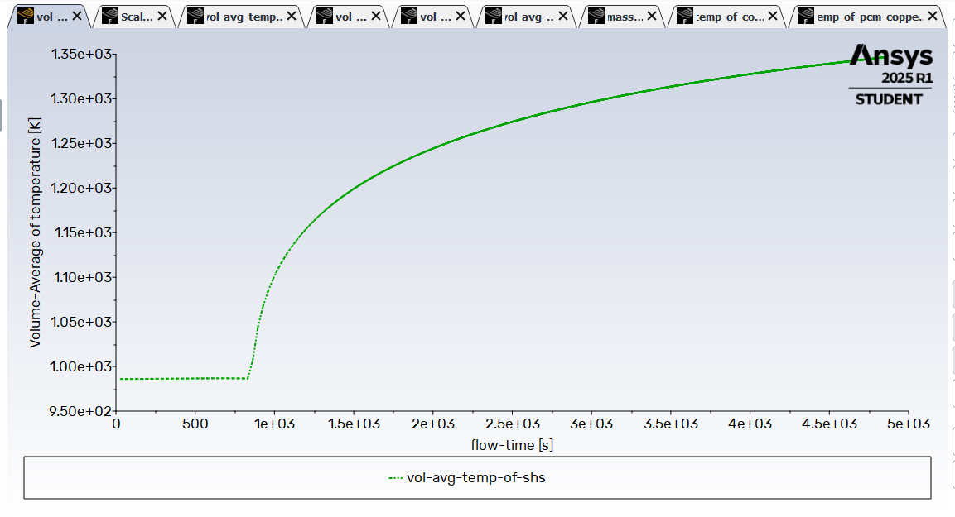

Enthalpy absorbed by Pcm in this time – 16,28,354 J/Kg

Enthalpy absorbed by Shs in this time 11,53,205 J/Kg

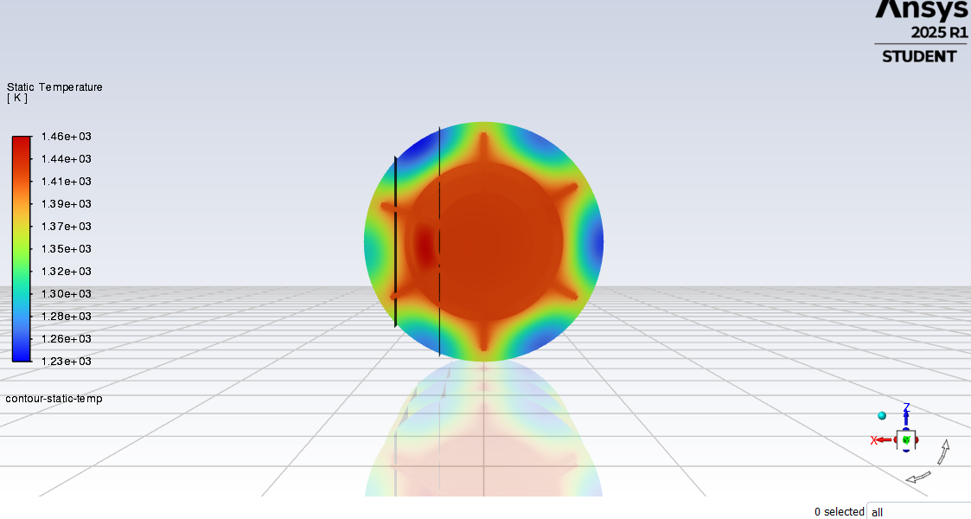

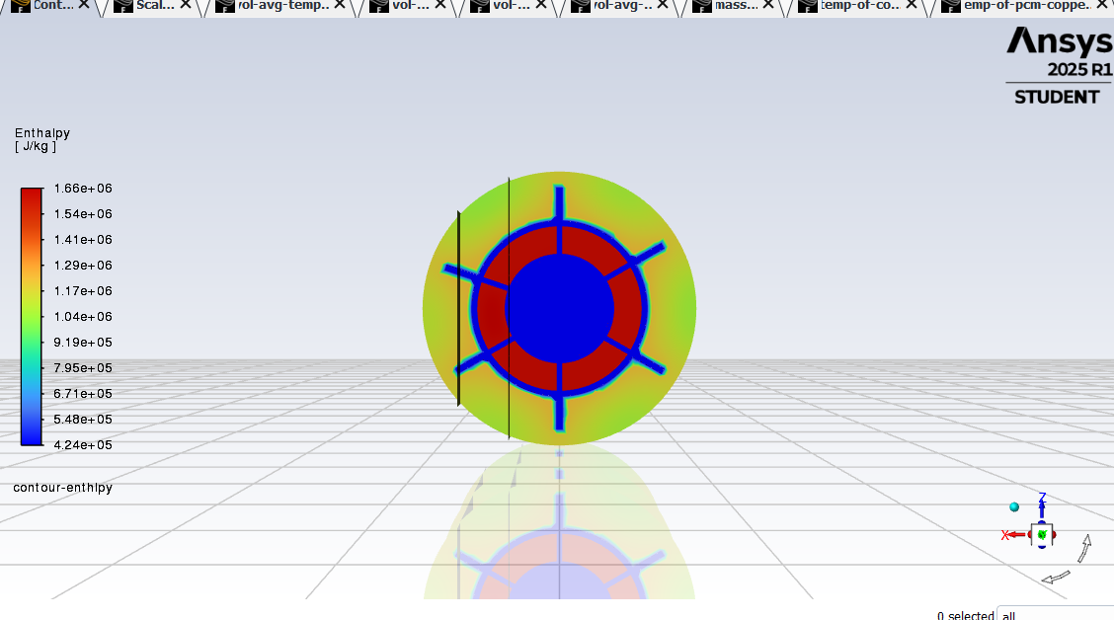

During my internship, I was involved in the design and simulation of a hybrid thermal energy storage system personalized for Concentrated Solar Power (CSP) applications. The objective was to evaluate and optimize the thermal performance of the storage system by leveraging simulation tools, with a focus on improving energy absorption efficiency.

Using ANSYS Fluent, I conducted transient thermal analyzes under varying orientations and thermal load conditions. One of the significant findings was that when the thermal storage apparatus was oriented at a 45-degree angle, there was a noticeable increase in enthalpy, which is 13.58% increment in absorption, indicating enhanced thermal charging behavior due to better natural convection and heat transfer characteristics.

This project deepened my understanding of hybrid thermal storage design, phase change materials, and simulation-driven thermal analysis, while strengthening my skills in numerical modelling, thermal systems, and simulation software. Overall, the experience was both technically enriching and practically insightful, offering valuable exposure to real-world research and sustainable energy innovation.

ROHIT CHAUHAN

Department of mechanical engineering

National Institute of Technology, Rourkela